Assembling the Barcode Scanner

* Open the barcode scanner box and remove all components of the scanner from the box. These components include:
  + Handheld BT Scanner
  + Lanyard Tether
  + (2) NiMH AAA Rechargeable Batteries
  + USB Charge Cable
  + USB AC-Adapter
* On the reverse side of the Handheld Scanner, take note that there is a large black screw in a vertical position: This holds the back of the scanner onto the device. Press firmly on the back and use a coin to **turn the large black screw counterclockwise 90 degrees**, the screw should now be in a horizontal position. *See example images*

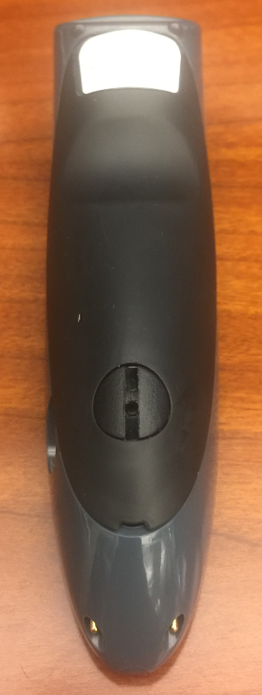 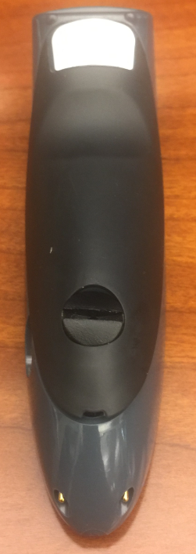

* Carefully attempt to **lift the back cover**.
* **Insert the Rechargeable Batteries** in the base of the Handheld Scanner, aligned as pictured inside the scanner. (Flat surfaces of the batteries go on the springs.) *See example images*
* Hold the back cover of the Handheld Scanner and flip it over so the inside of the cover is facing you. **Wrap the small rope of the Lanyard Tether around the locking mechanism** (the inside of the large black screw you have turned sideways). Hold the Lanyard Tether such that the rope remains taut and firm. *See example images*

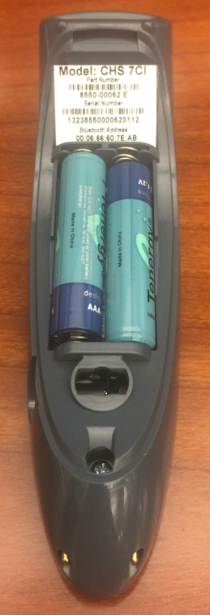 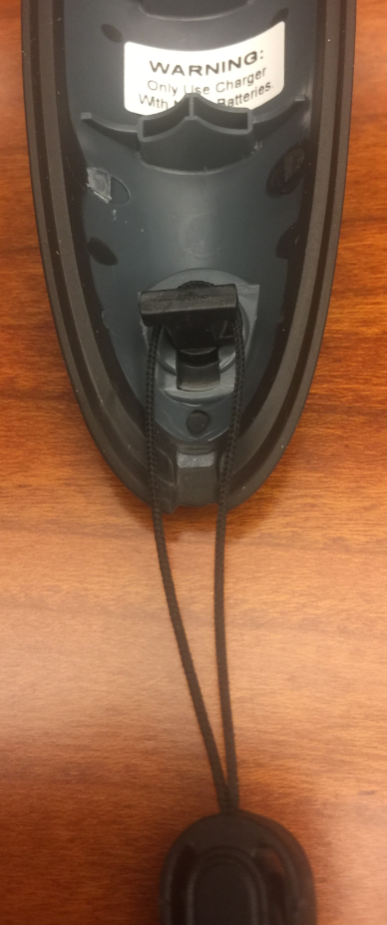 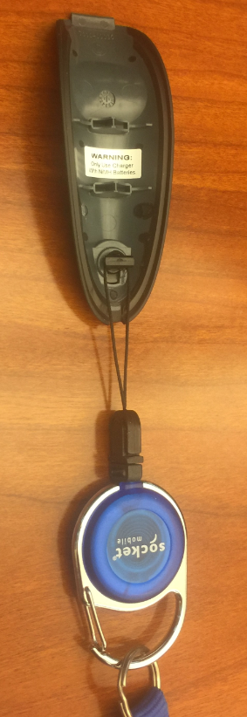

* Carefully **replace the back cover** while holding the Lanyard Tether firmly (**insert the top section** of the back cover **first**. Ensure the batteries hold in place once the cover is replaced back on the Handheld Scanner. *See example images*
* Press firmly on the back cover, and **turn the large black screw clockwise 90 degrees**, the screw should now be in a vertical position. *See example images*

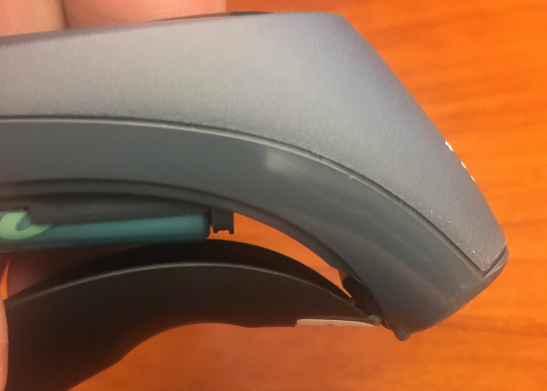 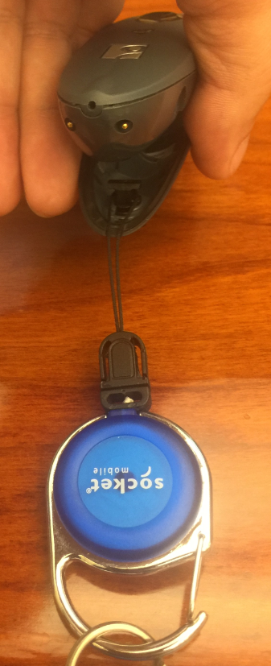 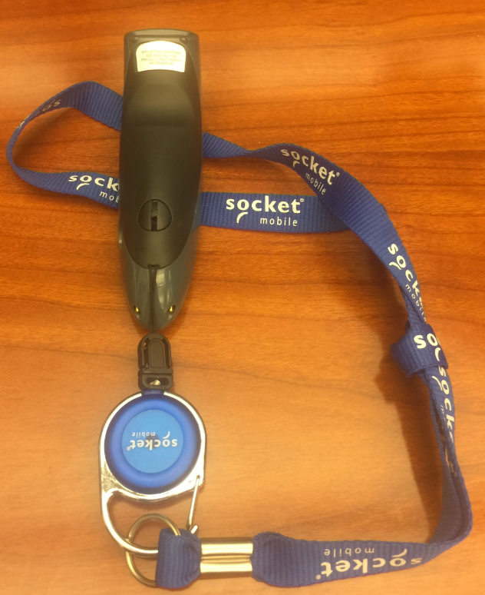

* **Tie the Lanyard Tether around the NCR iPad Base**. *See example image*

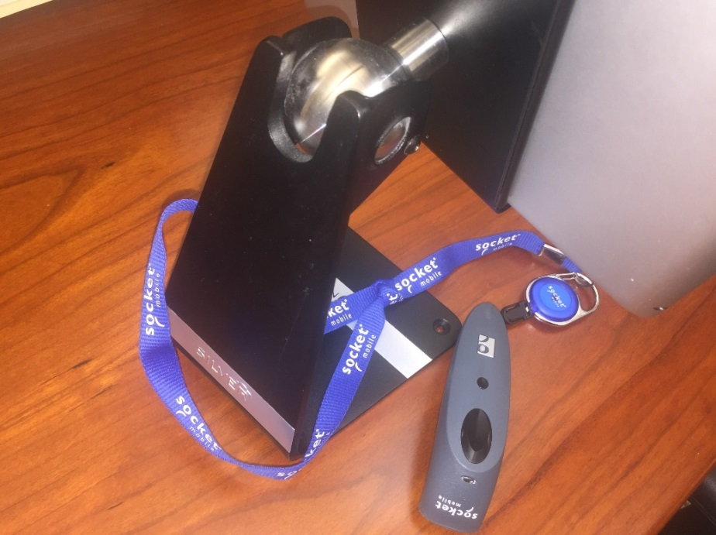

* Plug the USB Charge Cable into the USB AC-Adapter. Plug the AC-Adapter into an outlet, and the smaller, rounded end of the cable into the round port on the side of the Handheld Scanner. This will start to charge the Handheld Scanner. The LED light (on front of the scanner) will turn red.