**Employees**

**Setting Up Your Employees**

Select the **Employees** tab at the top of your NCR Silver back office.



This screen displays all of the employees that have been added to your account.  You are also able to search for employees based on criteria you specify, such as email address or phone number. Double Click on an employee’s name to update information their information, and/or remove an employee.

This page is also where you add new employees, select

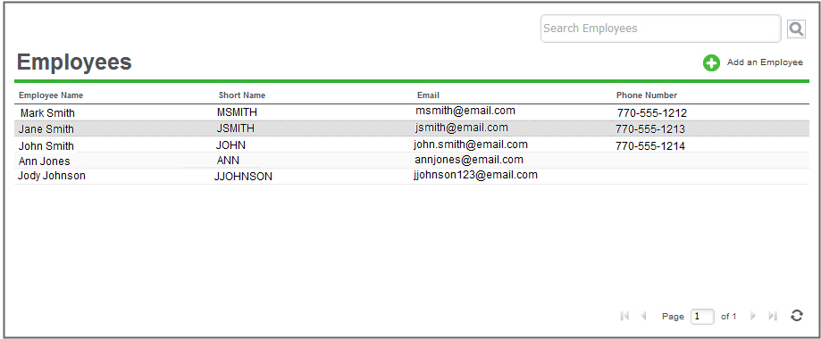

**Adding Employees**

To add an employee:

1. Select **EMPLOYEES > EMPLOYEES**.
2. Click **Add an Employee**.  The system will display the **Employee Detail** screen.
3. Enter the **Employee Name**, **Short Name**(will be shown on reports and receipts).  You can use initials, first name, last name, etc.), **Email Address** (required if the employee will have Back Office access), and **Phone** for the employee.

**NOTE:**  You can optionally enter alphanumeric characters in the **Employee ID**field. NCR shows this field on the Time Clock report, so you could enter a payroll ID to aid in payroll/accounting.

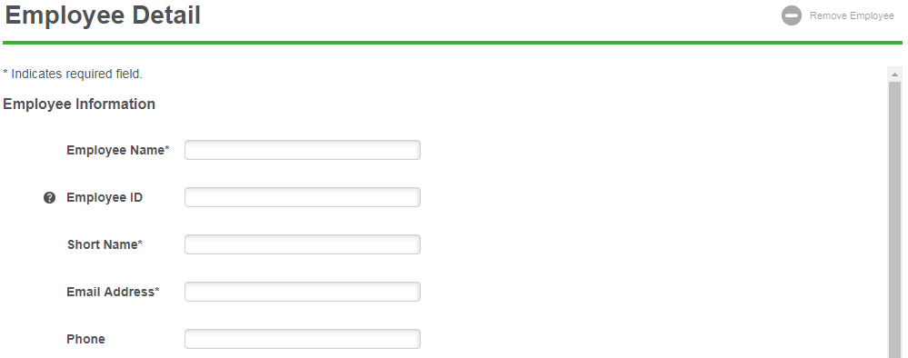

1. Select the **User Role**field and select the user role for the employee.

**System User Roles**

* **Store Manager (Franchisee)**
  + Designed for managers who need full access to all of the features in the POS app and full access to the Back Office, with the exception of account setup, purchasing, and billing features
* **Cashier Plus**
  + Designed for employees who need full access to all of the features on the POS device, as well as inventory management in the Back Office
* **Cashier**
  + Designed for employees who ring up sales on the POS device, but do not access the Back Office
* **Time Clock Only**
  + Designed for employees who will only use the POS device to clock in/out

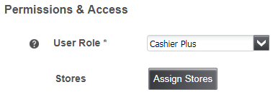

1. Click the **Assign Stores**button and select the store where the employee will be working.
   * You will see all Cellairis locations in the section, all locations except yours will be greyed out. Use the Search Store tool to easily locate your location.

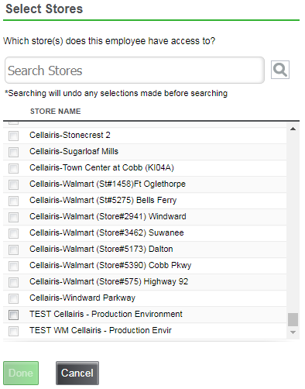

1. The screen will update the **Login Credentials**based on the user role you select.  Complete the following information as designated by the user role:

* Enter a Back Office **User name** for the employee, (does not have to be an email)
* Enter a unique **4 to 8 digit** **PIN**for each employee who will need access to the POS app and/or just to clock in and out without access to other POS app functions.  Remember to give the PIN to the employee.
* Enter a Back Office **Password** and then enter it again in the **Confirm Password** box. This is a temporary password. When the employee logs in for the first time they will be asked to enter a new password.

1. Click **Save Changes** to save the new employee record.  Repeat these steps for each employee.