Setting Up The Barcode Scanner

* **Press and hold down the small Power Button** (for three seconds) until the LED light turns blue and the scanner beeps twice.
  + The LED should blink blue once per second: This means the scanner is turned on, but not paired to the POS yet.

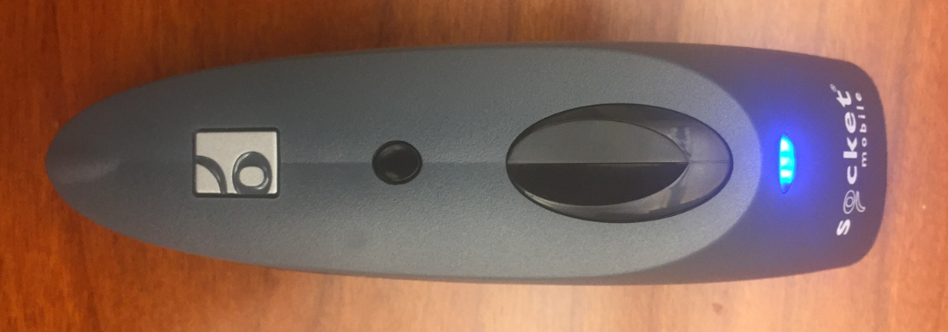

**Power Button Button**

**LED**

**Scan Button**

* On your iPad, **open the Settings menu** 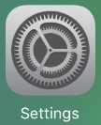 and **select Bluetooth**. Bluetooth must be active on your iPad for the Scanner to connect to your POS. Keep this menu open. *See below image*
  + **DO NOT** connect to the Socket CHS (Bluetooth Scanner) yet.

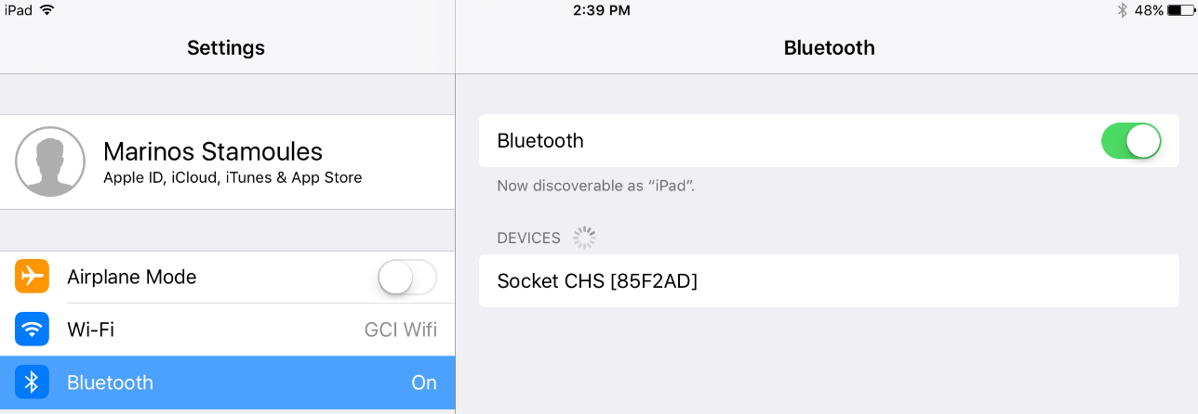

* Press the large Scan Button on the Handheld Scanner and **scan the following barcode**:

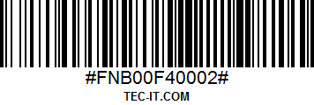

* + Several confirmation beeps will be heard from the scanner, the scanner is now broadcasting that it is pairable by Bluetooth.
* On your iPad, a device should be discoverable in your Bluetooth menu titled “Socket CHS [######]”. (The # symbols will be different for each scanner used.) **Tap the “Socket CHS [######]”** line on the iPad to connect to the Bluetooth scanner. *See below image*

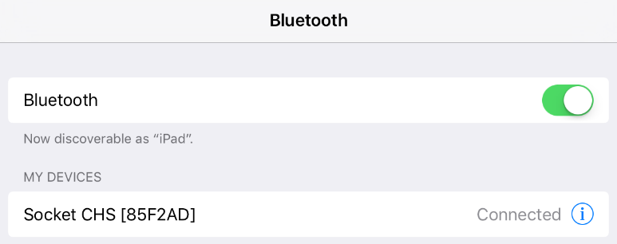

* The Handheld Scanner is now connected to the iPad!
* Close out of the Settings App and **open the NCR Silver app**. 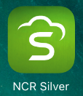
  + Use a Store Managers pin to log into the app
* Top-left corner of the NCR Silver POS screen **select  to access the menu** (the button looks like three parallel horizontal lines)

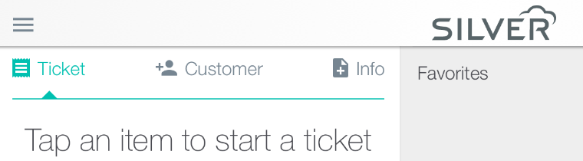

* **Select Settings** within this Menu (located near the bottom of the screen). 
* Within the Options menu *(defaults here)*

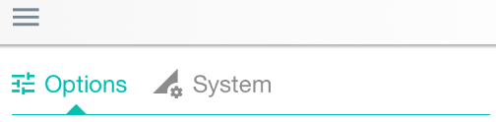

* + **Scroll to the bottom** of the options menu and **select: Use Bluetooth Barcode Scanner** (the slider will appear Green once selected. *See example image*



* Once the Bluetooth Barcode Scanner is paired, the LED will blink blue once per every 3 seconds.